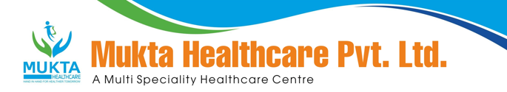

**MONTHLY BIO-MEDICAL WASTE REPORT**

For the Month of February,2024

1. Name of the Health Care Unit: Mukta Nursing Home
2. Address: Medical More, Sarada pally, Shiv Mandir, Siliguri 734011, Contact No: 9733533535
3. Category-wise (As per Schedule of the Rule) generated and quantity for the month of **February, 2024**.

|  |  |  |
| --- | --- | --- |
| Category | Count(Bags) | Waste Quantity(Kg) |
| YELLOW | **92** | **128.50** |
| RED | **48** | **82.00** |
| 1WHITE(Sharp) | **2** | **2.00** |
| Blue(Glass) | **10** | **22.00** |

1. Category-wise total quantity of waste sent to common BMW treatment facility.
   1. Incineration/Burial (yellow bags):**128.50**Kg. (Own facility/Common BMW treatment

facility)

* 1. Autoclave/Microwave:

(a)Red Bag:**82.00**Kg(Own facility/Common BMW treatment facility}

(b)Sharp Container**2.00**kg.(Own facility/Common BMW treatment facility)

1. Any other relevant information.
2. Certified that the above report is for the month of **February,2024**.

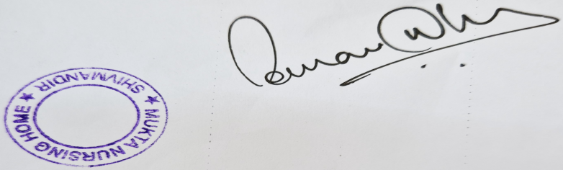

Dr Sourav Dhar

Managing Director

