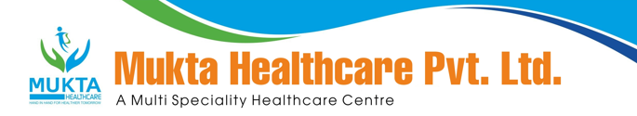

**MONTHLY BIO-MEDICAL WASTE REPORT**

For the Month of Aug,2024

1. Name of the Health Care Unit: Mukta Nursing Home
2. Address: Medical More, Sarada pally, Shiv Mandir, Siliguri 734011, Contact No: 9733533535
3. Category-wise (As per Schedule of the Rule) generated and quantity for the month of **Aug, 2024**.

|  |  |  |
| --- | --- | --- |
| Category | Count(Bags) | Waste Quantity(Kg) |
| YELLOW | **67** | **87.5** |
| RED | **52** | **82.00** |
| 1WHITE(Sharp) | **1** | **0.50** |
| Blue(Glass) | **1** | **1.50** |

1. Category-wise total quantity of waste sent to common BMW treatment facility.
   1. Incineration/Burial (yellow bags):**87.50**Kg.(Own facility/Common BMW treatment

facility)

* 1. Auto clave/Microwave:

(a)Red Bag: **82.00** Kg(Own facility/Common BMW treatment facility}

(b)Sharp Container **0.50**kg.(Own facility/Common BMW treatment facility)

1. Any other relevant information.
2. Certified that the above report is for the month of **Aug,2024**.

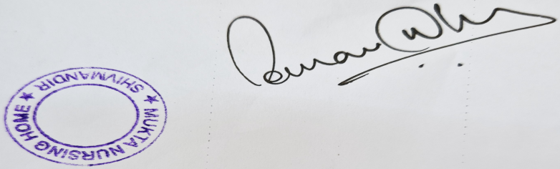

Dr Sourav Dhar

Managing Director

